FALKRIK COUNCIL: LOCAL HEAT AND ENERGY EFFICIENCY STRATGEY DELIVERY PLAN
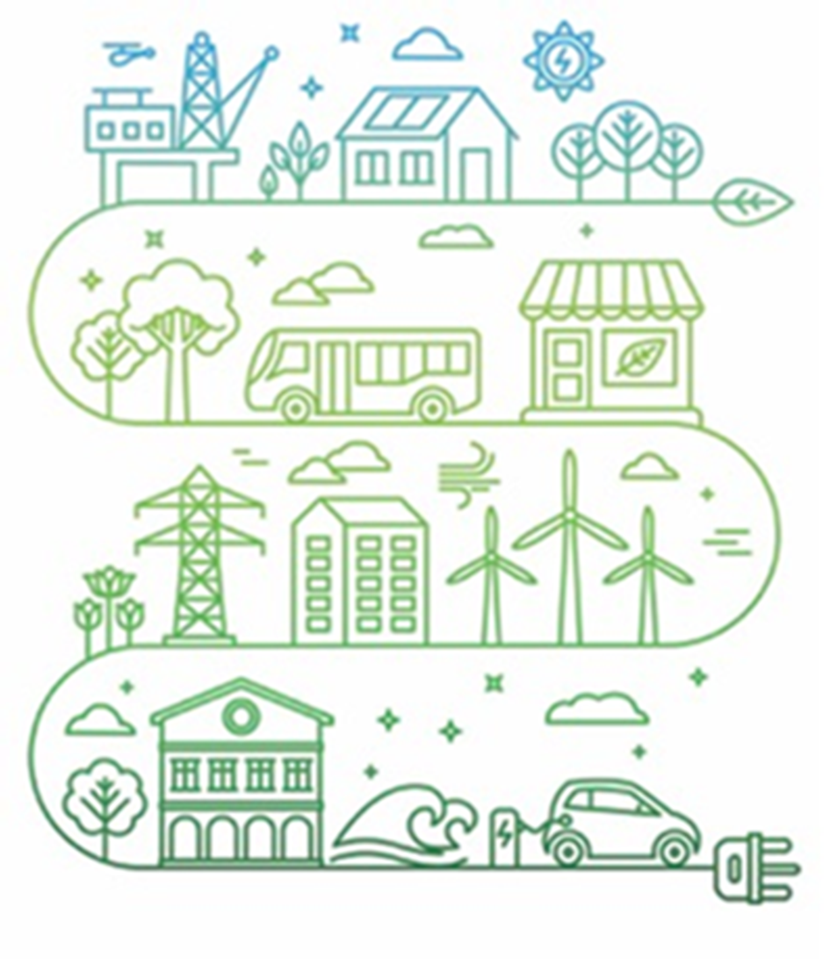

Table of Contents
1 Glossary 4
1.1 Abbreviations 4
1.2 Terms 5
2 Introduction 9
2.1 Aim of this document 11
2.2 Structure 11
2.3 Summary of LHEES Strategy Findings 12
3 Current Projects 15
3.1 Overview of projects 15
3.2 Project details 17
3.2.1 Heat Network Feasibility Study 17
3.2.2 Hallglen Solar Farm 21
3.2.3 Waste to Energy Plant Earlsgate 23
3.2.4 Braes Villages ASHP Project 25
4 Potential Future Projects 27
5 Conclusion 32
6 Monitoring and Evaluation 34

Table of Figures
Figure 1: Map of Heat Network area, outlining heat off-takers 14
Figure 2: Map of heat demand surrounding Callander Park (Scotland heat Map, 2023) 15
Figure 3: Map of falkirk, Highlighting Hallglen (Google Maps, 2023) 17

List Of Tables
Table 1: Overview of current projects 10
Table 2: Heat Demand for highlighted areas (Taken from Scotland Heat Map, 2023) 16
Table 3: Overview of potential future projects 20

Glossary

Abbreviations
Acronym | Description
EES | Energy Efficient Scotland
EESSH | Energy Efficiency Standard for Social Housing
EPC | Energy Performance Certificate
EST | Energy Savings Trust
GIS | Geographical Information System
HEEPS:ABS | Home Energy Efficiency Programmes for Scotland: Area Based Schemes
IZ | Intermediate Zone
LA | Local Authority
LHEES | Local Heat and Energy Efficiency Strategy
LPG | Liquefied Petroleum Gas
mxd | Map Exchange Document
PEAT | Portfolio Energy Analysis Tool
RSL | Registered Social Landlord
SAP | Standard Assessment Procedure
ToC | Table of Contents
UPRN | Unique Property Reference Number

Terms
Terms | Description
Baselining | Baselining is the purpose of understanding at local authority or strategic level, the status of the buildings against the LHEES Considerations, Targets and Indicators.
Building-level Pathway | As part of LHEES Stage 5, a building-level pathway is the outcome of the assessment undertaken using PEAT. It provides the likely energy efficiency retrofit technologies, as well as the low carbon heating system (where applicable) to support building level decarbonisation.
Criteria | Criteria are the settings applied to the Indicators for each Consideration to support Baselining, Strategic Zoning and the identification of Delivery Areas. An example of Criteria is a simple “no” applied to the indicator of “wall insulation (Y/N)” to identify properties with uninsulated walls. Another example is the definition of an “anchor load” within the Heat Network zoning analysis, which applies a minimum threshold to the “heat demand” Indicator. The LHEES methodology provides a set of default Criteria that local authorities may wish to use, with flexibility to update and augment these to support local needs or for more focused analysis linked to specific actions and project identification within the Delivery Plan.
Data - Alternative | Alternative data can overwrite the Core data to improve accuracy (national to local level of detail, e.g., local housing data to overwrite fields in Home Analytics).
Data - Core | Core data is the data that is essential to complete the minimum requirements of the LHEES analysis. Core data will come from national datasets e.g., Home Analytics or the Scotland Heat Map.
Data - Supplementary | Supplementary data allows inclusion of additional Indicators to inform specific, local priorities & targets; also, Supplementary data can be used in GIS investigation to complement the Core analysis carried out in any assessment. An example of Supplementary data would be the inclusion of an appraisal of constraints as part of a district heating analysis.
Data Zone | Data zones are groups output areas which have populations of around 500 to 1,000 residents.
Delivery Area | Delivery areas are at a higher granularity than Strategic Zones. These spatial zones should set out clusters of buildings within a Strategic Zone or across the whole local authority that identify potential solution(s) at a delivery level. They will be an important starting point for identifying a range of projects, regulation and actions that are within the competence of the Scottish Government, local authorities and wider partners (included as actions to be developed in the LHEES Delivery Plan).
Detailed practitioner approach | These Steps form part of the detailed practitioner approach in LHEES Stage 4, Generation of Initial Areas to set out particularly suitable heat network zones and to support project identification.
Indicator | For a given Consideration, the purpose of an Indicator is:  1) to act as a key information field to help characterise and baseline the local authority.  2) to act as a key information field to support strategic zoning and generation of initial delivery areas.  3) if suitable, to act as a key information field to measure progress against Targets over the duration of the LHEES - set out in the LHEES Delivery Plan.  For some Considerations, one Indicator may be sufficient, but for others a range may be appropriate.
Intermediate Zone | Intermediate zones are a statistical geography that are designed to meet constraints on population thresholds (2,500 - 6,000 household residents), to nest within local authorities, and to be built up from aggregates of data zones.
LHEES Considerations | The LHEES Considerations are a list of technologies, building typologies and policy priorities used to identify and target interventions. They include:  - Heat networks  - Off-gas grid buildings  - On-gas grid buildings  - Poor building energy efficiency  - Poor building energy efficiency as a driver for fuel poverty  - Mixed-tenure, mixed-use and historic buildings
LHEES Delivery Plan | An LHEES Delivery Plan is a document setting out how a local authority proposes to support implementation of its local heat and energy efficiency strategy.
LHEES Guidance | The LHEES Guidance sets out the production and content requirements for a local authority to prepare a Local Heat and Energy Efficiency Strategy and Delivery Plan. Its purpose is to ensure that a Local Heat and Energy Efficiency Strategy and Delivery Plan contain outcomes and actions that are backed up by robust data and analysis, supported by stakeholder engagement, and that are linked to national and local priorities, plans and targets.
LHEES Methodology | The LHEES Methodology is a more detailed, step by step approach, which includes models, tools and templates, and represents best practice in how to produce an LHEES in accordance with the requirements set out in the LHEES Order and Guidance.
LHEES Stages | There are 8 LHEES Stages proposed in this methodology. The purpose of the LHEES Methodology is to enable the local authority to complete LHEES Stages 1 to 6. The completion of these Stages will provide the local authority with the data analysis and evidence base to enable them to complete their LHEES Strategy and Delivery Plan documentation. There are two LHEES reporting templates included alongside this methodology– LHEES Strategy example template and LHEES Delivery Plan example template. The completion of these two templates will satisfy the completion of LHEES Stages 7 and 8. The 8 LHEES Stages proposed in this methodology are:  1 - Policy and strategy review  2 - Data and tools library  3 - Strategic zoning and pathways  4 - Generation of initial delivery areas  5 - Building-level pathway assessment  6 - Finalisation of delivery areas  7 - LHEES Strategy  8 - LHEES Delivery Plan
LHEES Strategy | An LHEES Strategy is a long-term strategic framework for—  - the improvement of the energy efficiency of buildings in the local authority’s area, and  - the reduction of greenhouse gas emissions resulting from the heating of such buildings
Mixed-tenure, mixed-use and historic buildings | Mixed-tenure and mixed-use buildings could include a mixture of owner occupied, private rented and social housing, and also non-domestic uses, or simply multiple ownership within the same tenure. Historic buildings include the buildings that are within conservation areas or those that are listed buildings. These categories may require established alternative approaches and regulation for the installation of low carbon heat and energy efficiency solutions and where specific advice and support might be available relating to the installation of these solutions.
Phase (Delivery Plan) | A suggested period of work to complete the initial LHEES Delivery Plan.
Raster | A matrix of squares, or grid, used as a method of data analysis in GIS. Each cell in the grid contains a value representing information on the cell’s contents.
Strategic Zone | Strategic Zones present a visualisation of the potential pathways to decarbonise the building stock at a local authority level. These could, for example, be split out by intermediate zone or data zone. They are useful to understand the baseline performance, the scale of potential and initial areas of focus, which could be used to inform Delivery Areas and follow on engagement.
Targets | Targets are the measurable aspect of the Consideration and are likely to be taken directly from national and/or local policy documentation, for example net-zero by 2045, or EPC C by 2040. Targets are likely to comprise of end-point targets and milestone targets and would sit along a timeline within (and beyond) the LHEES. This timeline would help to prioritise the types of projects undertaken within the LHEES over its duration.
Weighting | For some Consideration, one Target and Indicator may be sufficient, but for others a range of Indicators may be appropriate to contextualise and characterise performance against a Target and/or progress towards a Consideration. If multiple Indicators are used in strategic zoning or the identification of delivery areas, a Weighting can be applied based on the importance of each. The LHEES methodology sets out a core set of default Weightings for instances where multiple Indicators are suggested as a default setting. There is flexibility to update and augment these to support local needs or for more focused analysis linked to specific actions and project identification within the Delivery Plan.

Introduction

As set out in the draft Heat in Buildings Strategy (Scottish Government, 2021). Local Heat & Energy Efficiency Strategies (LHEES) are at the heart of a place based, locally led and tailored approach to the heat transition. These local strategies will underpin an area-based approach to heat and energy efficiency planning and delivery. LHEES will set out the long-term plan for decarbonising heat in buildings and improving their energy efficiency across an entire local authority area.

LHEES is primarily driven by Scotland’s statutory targets for greenhouse gas emissions reduction and fuel poverty:

- Net zero emissions by 2045 and 75% reduction by 2030.
- In 2040, as far as reasonably possible, no household in Scotland is in fuel poverty.

For the Falkirk Council area, the accompanying LHEES Strategy, which can be found in a separate document will:
- set out how each segment of the building stock needs to change to meet national and local objectives, including achieving zero greenhouse gas emissions in the building sector, and the removal of poor energy efficiency as a driver of fuel poverty;
- identify strategic heat decarbonisation zones, and set out the principal measures for reducing buildings emissions within each zone; and
- prioritise areas for delivery, against national and local priorities.

The purpose of the LHEES Strategy is to present the evidence base that identifies what needs to be done across the local authority to change buildings and local infrastructure by 2045 to fulfil the Scottish Government’s objectives and local priorities relating to heat in buildings. The interventions as set out occur at the building level, in heat networks or in a combination of both. The strategy reflects national and local priorities, policies, and wider strategies. Where feasible, it considers local and national factors, such as the timing of planned infrastructure upgrades, access to resources, major projects, decisions over the gas grid and stakeholder/community engagement.

Accompanying the LHEES Strategy is this LHEES Delivery Plan, which has been developed in partnership with key stakeholders, and provides a strong basis for action for local communities, government, investors, developers and wider stakeholders, pinpointing areas for targeted intervention and early, low-regrets measures. This Delivery Plan sets out how Falkirk Council proposes to support implementation of its local heat and energy efficiency strategy. This LHEES Delivery Plan incorporates actions with a near-term (5-year) focus.

Aim of this document

This Delivery Plan sets out potential short-term actions stemming from the LHEES Strategy document, providing a prospectus for where government funding and private investment for heat decarbonisation and energy efficiency investment is being targeted and should be targeted.
As a forward-looking long-term strategy to be produced in 5-year cycles, the LHEES Delivery Plan sets out a direction of travel rather than new policies. It will set out pathways and actions through which national targets could be met and as actions are developed over time impact assessment requirements, including SEA and EPIA, will be considered at the appropriate scale and points in delivery. The LHEES Delivery Plan will set out actions enabling Falkirk Council and its partners to work towards delivery of the LHEES Strategy. Actions will contribute to achieving Scotland’s statutory targets on net zero greenhouse gas emissions and fuel poverty, as well as enabling the delivery of changes to buildings and local infrastructure needed to fulfil the Scottish Government’s objectives relating to heat and energy efficiency in buildings. The Delivery Plan will clarify stakeholder roles and responsibilities in delivering the LHEES; build on existing plans and policies, such as HEEPS:ABS Plans, as far as possible and; coordinate across local partners and provide a mechanism for identifying new delivery actions.
It is important to note that identified areas for delivery and action through this LHEES Delivery Plan will be indicative only. Any site-specific impacts will be more substantially assessed at the detailed planning and implementation stage where required.

Structure
This Delivery Plan follows on from the accompanying LHEES Strategy, taking the strategy findings and outlining decarbonisation projects in the Falkirk Council area. This plan will provide a summary of the LHEES strategy findings, outlining the key areas of delivery and potential avenues for intervention. The plan will the outline decarbonisation projects ongoing within the Council, providing a detailed overview for each project. The plan will then cover a list of potential projects that the LHEES Strategy has highlighted as potential future avenues for decarbonisation. The first LHEES will cover the period 2024 to 2029, with a duty for LHEES Strategy and Delivery plan to be prepared every 5 years.

Summary of LHEES Strategy Findings
Overall, several strategic zones with potential heat decarbonisation and energy efficiency intervention have been highlighted across the Falkirk area. As seen in table 1, when considering the Falkirk Council area, Falkirk Grahamston, Bo’ness Kinneil and Braes Villages have been highlighted for high levels of poor energy efficiency, high level of fuel poverty and each zone has a range of possibility for retrofit. For the Falkirk Council owned domestic properties, the top areas for poor levels of energy efficiency were Falkirk North, Grangemouth, and Upper Braes. These areas will be of focus throughout future HEEPS ABS work.
Table 1: Zones where poor energy efficiency is likely to be a driver of fuel poverty (Taken from Falkirk Council baseline tool,2023)

This strategy has outlined the potential for a range of decarbonisation intervention across the council area. Heat Networks, ASHP retrofit and fabric improvements being the key drivers for decarbonisation. The Strategy document provides map which visually present areas of the council where retrofit, such as ASHP could be suitable, figure 1 demonstrates this. Once a zone has been highlighted for intervention where further investigation can be done. The area surrounding Falkirk Grahamston is urban and poses a suitable opportunity for a heat network. As outlined within the accompanying Delivery Plan, potential extension of the current heat network at Callander Park could reach the Falkirk Grahamston area. Bo’ness Kinneil has more opportunities for intervention. The strategy findings highlight the possibility of an ASHP project in the area as there are pockets with good levels of insulation. Additionally, there are options for a heat network in this area, using local infrastructure and the possibility of tapping into mine water heat or sewage heat. The Brae’s villages are mainly rural and therefor a heat network will not be suitable. Expansion of the current ASHP work going on here will pose as most beneficial.

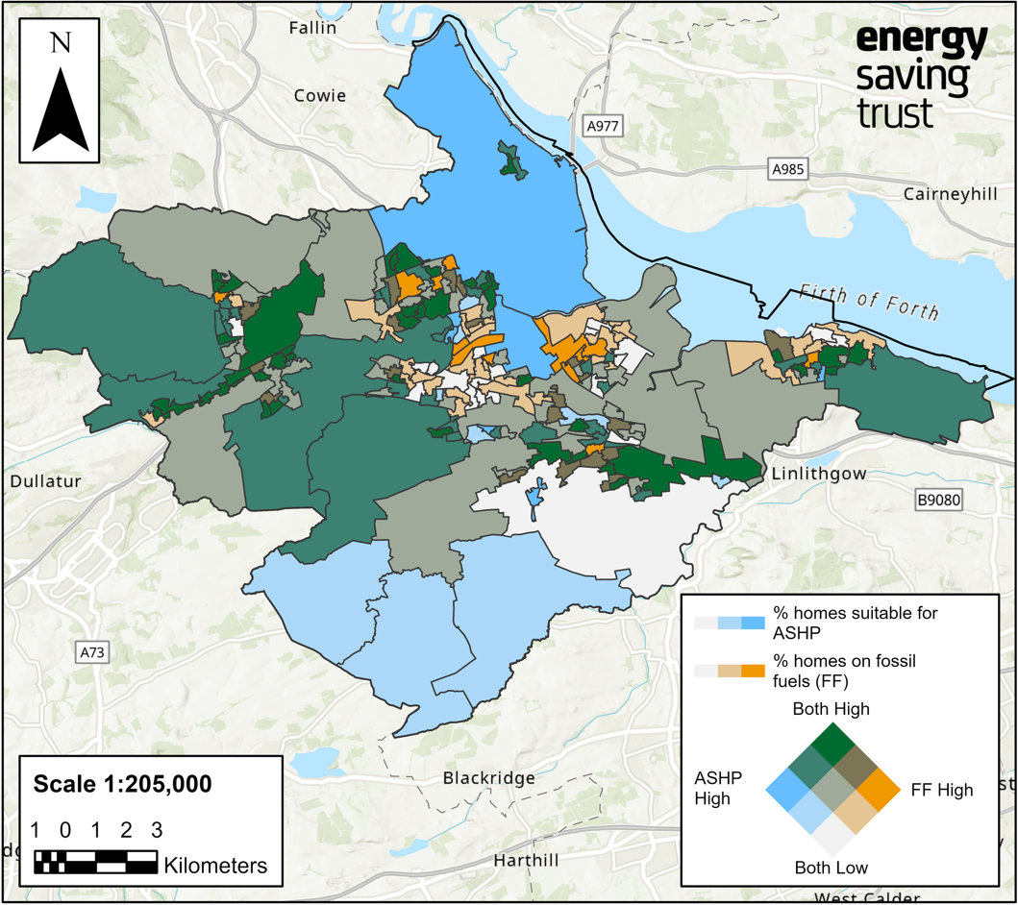
Figure 1: Map highlighting areas within Falkirk Council that could be suitable for ASHP retrofit (EST, 2023)

This accompanying Delivery Plan will outline all projects, both current and future, that will assist Falkirk Council in decarbonising heat and reaching crucial carbon emission targets. Several of the projects within this Delivery Plan reflect the findings found within this Strategy and include projects relating to ASHP retrofit, heat networks and the potential for tapping into mine water and sewage. Even with these projects in place, Falkirk Council has a long way to go to reach Net Zero carbo emissions from buildings. The Strategy and Delivery Plan will be updated every 5 years to reflect this, and we will continue to assess our building stock to kickstart relevant decarbonisation projects.

Current Projects

Overview of projects
Table 1 outlines detail of current projects taken from LHEES Strategy data analysis and other key projects within the council area related to energy efficiency and decarbonisation. These projects range from feasibility studies to on the ground projects. Further detail of each project can be found in following section 3.2. It I important to note that these are significant projects. Projects such as EESSH and HEEPS ABS will still be ongoing throughout the LHEES process and cover fabric first areas.
Project | Description | Timeline/Progress | Resources | Comments
Heat Network Feasibility Study | Extension and decarbonisation of the current heat network and Callendar Park, with potential to extend up to the Town Centre (inclusive of several homes and businesses in between. | Feasibility Study: Now – March 2024  Business Case: July 2024-January 2025.  Commercialisation: February 2025-February 2026  Delivery: April 2026-March 2027 | Heat Network Support Unit and grant support through feasibility and business case. | This project is overseen by the Energy & Climate Change Team. Areas covered by the proposed expansion have a high heat demand of over 625,000 kWh/yr, which could result in a significant carbon saving.
Hallglen Solar Farm | Solar Farm development at Woodend farm, Hallglen. Estimated annual yield for 2.5MW solar array at Hallglen is 3,045 MWh. The proposed development is situated within the Scottish and Southern Electricity  Networks (SSEN) distribution network area and has a budget of £325,000. | Feasibility Study phase 1– Complete June 2023  Phase 2 feasibility study to consider additional private wire connections. – February 2024.  G99 application submitted in quarter 1 of 2024. | Consultancy support to carry out phase 2 of study.  Support for business case development | With a 2.5MW Solar PV installation, a total of 3,054MWh of electricity could be produced in a year. It has been determined that approximately 9% of the power generated would be consumed by the site demand, according to the half hourly data provided by  GEP. 91% of the total production would need to be exported to the grid.  Considering phase 2 of the study to look at additional connections, via private wire, to the solar farm. This includes connecting into heat network at Callendar Park.
Waste to Energy Plant Earls Gate | The council has appointed waste contractors Cireco on a ten-year contract to convert household waste from the area into electricity and steam at the new Earls Gate Energy Centre in Grangemouth. The power generated by the process is enough to supply the energy needs of running the plant as well as 20,000 homes. | Pre-feasibility and feasibility studies were carried out between 2022 and 2023.  Work regarding commissioning should start autumn 2023 the plant being fully operational early 2024. | Support through waste contractors Cireco. | The Earls Gate Energy Centre (EGEC) is an Energy-from-Waste Facility (EfW), jointly owned by Brockwell Energy, Covanta and Green Investment Group, in Grangemouth, Scotland.
Braes Villages Green Energy Solution Programme | The Braes Villages, a rural area of Falkirk Council, are currently due to get gas connections fitted between 2024/2025. As well as the plan to extend the gas network to the villages noted above, the council have also offered tenants in these areas the option to consider an alternative ‘Green Energy Solution’. This option includes the  installation of an Air Source Heat Pump, complemented by Solar PV and  battery storage. | To date the council have completed a 28-address pilot for the ASPH & PV works, and now have 100 addresses progressing as phase 2.  Phase 3 will depend on how may tenants decide to take up the ASHP. | Scottish Government Grant funding - Green Energy Solution Programme funding bid has been successful in phase 1 and 2.  A further bid will be made for phase 3. | The address list is continually being updated as people are getting in touch and asking to be included, any left over from the 100 will fall into Phase 3. Some who said yes originally have changed their minds, but this could be for varying person reasons. Scottish Government Grant funding was used to progress these works, the Client Housing sourced this themselves and the contracts have been procured through the framework so far.

Table 2: Overview of current projects

Project details

This section will take the current projects outlined above in turn and provide further detail.

Heat Network Feasibility Study

Background
Work is currently in the very early stages of initial analysis. Through the completion of the LHEES Strategy, the heat network analysis has allowed us to study the heat demands within the Falkirk area. Falkirk has a history of district heat network suitability studies. The terrain and dynamic of the council areas has meant that train lines, canals and motorways have prevented many heat network possibilities from preceding. As stated, there is currently a district heat network at Calendar Park in Falkirk. Development plans for this began in 2010 with a focus on addressing fuel poverty, improving infrastructure and the built environment, improving the environment, and ensuring early intervention. The Callendar Park Estate was built between 1965 – 1975, consists of 9 multi-story blocks, 5 that had electric heating and 4 that were mixed gas/electric heating. Noting that many of these electric heating systems were due for replacement. This estate was popular with elderly residents and was in the bottom 15% SIMD in 2009. Tenant consultation consisted of a tour of a similar network in Aberdeen, exhibitions, individual tenant appointments demonstration flats and regular newsletters.
The project qualified for 40% grant funding from the Community Energy Partnership and the Energy Efficiency Commitment Fund. gas fired CHP system was chosen with the potential to change to biomass in the future, tenants would get a controllable heat interface unit, hot water 24 hours per day and have unmetered heating with fixed weekly costs. Additionally, CHP offered lower carbon emissions compared to previous systems. The heat network consisted of a 1.12MW Gas CHP engine and a 2MW top up boiler. Initially 6 blocks connected to the heat network (504 flats) and the SAP rating improved from 35 to 68. In 2011 the Callendar House Museum connected to the network. 36 of the connected flats were owner occupied, 14 of these gained funding through either HEEPS:ABS or The Central Heating programme.

Project Outline
Falkirk Council officers are working with the Zero Waste Scotland (ZWS), through the Heat network Support Unit (HNSW) to compete a feasibility study looking at the possibility of setting up a low carbon heat network in the Callendar Park area. There is currently a gas CHP system that powers 9 of the 11 tower blocks in the area and provides power to Callendar House which is owned and run by the Council. This system will be requiring an upgrade in the next five years and so presents a key opportunity to upgrade and extend the current system. The extension of the system would still power the above and extend to the Callendar Business Park adjacent from the site and across the road to the two Schools (St Andrew’s Primary and Graeme High).
The system at Callendar Park will cover 11 tower blocks which house Falkirk Council social housing tenants and around 10 buildings within the business park hosting several organisations including one of Falkirk Council’s offices. It would also cover the primary and high school across the road. The map in figure 1 highlights these areas. Officers are also exploring the extension of the heat network to the Town Centre. The heat off-takers here would likely be houses (mix of social and private) around the area between Callander Park and Town Centre, figure 1, and would also cover the site of the Council’s Town Hall which will be where Callander Square Shopping Centre currently stands.
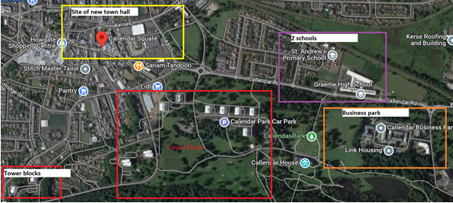
Figure 2: Map of Heat Network area, outlining heat off-takers

Heat Demand and Suitability
Officers have assessed that Callendar Park is a potentially suitable area for a heat network due to the number of buildings and the mix of domestic and non-domestic properties. The new Town Hall will require a low/zero carbon heating system and therefore, identified this as a potential building for extending the heat network to. Crucially, the current CHP system will need replaced within the next five years and a low carbon alternative will be important for reaching out emission targets.

Figure 2 indicates the heat demands for the suggested areas the heat network will extend to. This analysis uses a 50m grid system for heat demand, the scale on the map highlights the heat demand for each 50m area. The following figures in Table 1 show the heat demand of these areas, highlighting that a number of these buildings have a very high heat demand of over 625,000 kWh/yr.

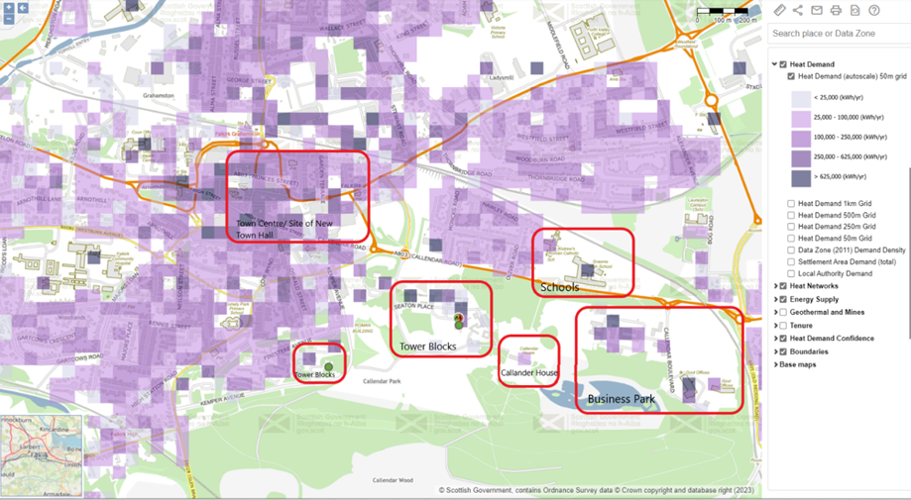
Figure 3: Map of heat demand surrounding Callander Park (Scotland heat Map, 2023)

Area | Heat Demand (kWh/yr)
Tower Blocks | Range from 250,000 – 625,000 to over 625,000
Callendar House | 25,000 – 100,000
Town Centre | Range from 100,000 to over 625,000
Business Park | Range from 25,000 to over 625,000
Graeme High School | Over 625,000
St Andrews Primary School | 100,000 – 250,000
Table 3: Heat Demand for highlighted areas (Taken from Scotland Heat Map, 2023)

Hallglen Solar Farm

Background
Falkirk Council officers have found a potential renewable energy source at Woodend farm, Hallglen (Figure 3). This area is owned by the council and currently a £27 million project is underway to build 111 new council homes on the site. Ethical Power Development (EPD) have been appointed by GEP Environmental (GEP) to carry out a review to determine the viability of developing a solar farm at Woodend Farm. The full land ownership area of the Woodend Farm is approximately 30 acres, of which the development area is around 8.3 acres, which is suitable for a solar array of up to 2.5MW. Noting that the proposed development site is within the SSEN distribution area. The 8.3-acre site is owned by FC and is known as land to the northeast of Woodend Farm. It comprises private greenfield agricultural land, parts of which appear to be used informally for walking. The estimated annual yield for a 2.5MW solar array in this location is 3,054MWh. Falkirk council as a history of successful ground mounted solar arrays that have been successfully approved for planning.

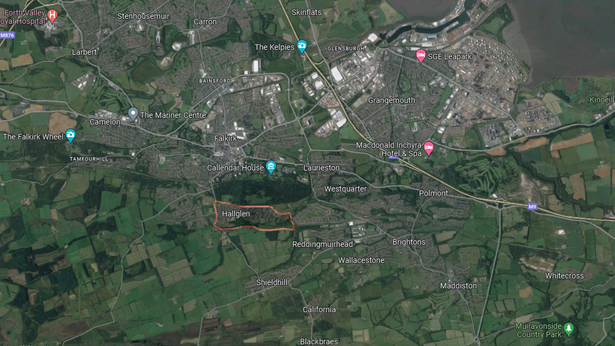
Figure 4: Map of Falkirk, Highlighting Hallglen (Google Maps, 2023)

Project Outline
The feasibility study considered heritage impacts, of which none are likely to have an impact and any landscape or ecology issue that may arise and likely to be outweighed by the benefits of the scheme. The study undertaken by GEP proposed 3 different scenarios for consideration. EDP has undertaken a high-level estimate on the capacity of the array that could be accommodated within the area. The Woodend Farm is around 30 acres, however, most of the land are either occupied by existing planting or secured for housing developments. The suitable area for solar is around 8.3 acres, therefore, an installed capacity of 2.5MW has been suggested. The following options have been suggested:
- Option 1: Build one site with 2.5MW of installed capacity, selling the electricity generated to three schools through sleeve Power Purchase Agreements (PPA).
- Option 2: Build three sites with a combined installed capacity of 2MW, selling the electricity generated to three schools through private wire PPA with separate wires.
- Option 3: Build three small sites with a total capacity of 232.2kWp, selling the electricity generated to three schools through private wire PPA with separate wires.
The feasibility study recommends that further checks on site constraints should be evaluated before a decision is made on what option to follow. This plan will be subsequently updated with this schemes progress. The high-level estimate, option 3 does not generate positive payback, due to significantly higher cost on the cable connections, with only 10% of the income compared to option 1. Therefore, currently only options 1 and 2 are being considered.

Waste to Energy Plant Earlsgate

Background
Falkirk Council has entered a new partnership that will ensure all waste that previously ended up in the ground will instead be turned into local energy. The council has appointed waste contractors Cireco on a ten-year contract to convert household waste from the area into electricity and steam at the new Earls Gate Energy Centre in Grangemouth. The new contract also fulfils the Scottish Government requirement of diverting biodegradable waste from landfill by December 31, 2025, while also meeting decarbonisation’ energy efficacy targets etc

Project Outline
The waste will be collected as normal from homes and household recycling centres, before being transported to Earls Gate in Grangemouth where it will be burned at extremely high temperatures of around 1000C and converted into ash, heat and flue gas that can be safely captured under the strictest national emission standards. The power generated by the process is enough to supply the energy needs of running the plant as well as 20,000 homes. It offers a much safer and environmentally friendly way of treating waste than landfill disposal which is especially harmful to the environment. Using this system means clean energy is created with the minimal of waste products generated.
The Earls Gate Energy Centre (EGEC) is an Energy-from-Waste Facility (EfW), jointly owned by Brockwell Energy, Covanta, and Green Investment Group, in Grangemouth, Scotland. The EfW at Earls Gate will be a fully integrated heat and power facility that will provide all the energy needs of CalaChem Ltd in its production of fine chemicals. The EfW retains sufficient capacity to produce additional electricity, steam and/or hot water for businesses, industry and residential purposes. It can process up to 216,000 tonnes of commercial and industrial pre-sorted waste every year, export more than 33MW of heat to CalaChem for industrial use and produce more than 22MW of electricity.
Benefits of the EFW Plant:
- Measurable contributions towards the 17 United Nations Sustainable Development Goals to be achieved by 2030.
- Recovery of up to 54,000 tonnes of recyclable materials comprising:
- 48,000 tonnes per annum of mineral aggregates
- 3,000 tonnes of ferrous metals
- 3,000 tonnes of non-ferrous precious metals
- Low-cost energy production and displacement of fossil fuels.
- Production of 77% of electricity from renewable biogenic materials.
- Treatment of 216,000 tonnes of municipal and other waste every year.
- Diversion of 210,000 tonnes of waste from landfill every year, reducing the impacts of pollution, odour emissions, and soil and water contamination.
- Raised awareness of and improvement in climate change mitigation through renewable energy.

Braes Villages ASHP Project

Background
Over the last 2 years, officers from Housing & Community Services have been working with the Scottish Housing Regulator and a group of tenant representatives, on the heating replacement project in the Braes Villages. The Council agreed on 29 September 2021 to extend the gas pipeline into the villages, a contractor has now been appointed and work will begin in October 2023. This was a controversial decision, as it does not fit in line with LHEES or our carbon reduction targets, fuel poverty was the main driver for decision making. It was agreed on 29th September 2021 that the following villages, Blackness; Standburn; South Alloa, Torwood, would have the option of alternative heating sources. 28 properties were involved in the phase 1 pilot.
Phase 1:
Phase 1 include Blackness, Standburn, South Alloa and Torwood. Scottish Government Low Carbon Funding was secured to provided PV/ASHP and Battery Storage design. The council accepted a contract and appointed Easy Heat to carry out these works. Installations started in April 2022 and took 10–12-weeks to complete.
Phase 2: Included Limerigg and gained funding through the Green Energy Solution Programme. 100 Properties were included in this phase and the council are currently appointing a company to complete these works.

Project Outline

For all phases, tenants received an information booklet which gave them the option of keeping their current heating system, being connected to the new gas network, or getting a green energy solution. The green energy solution compromises of ASHP and Solar PV. Currently the council are preparing for phase 3 and are awaiting feedback from tenants on what heating system they want installed. Noting that information regarding the green energy solution was provided to each tenant to assist with their decision. Following the first letter to tenants that was sent out in February 2022 which included a questionnaire regarding heating options, around 100 tenants noted a preference to consider the Green Energy Solution. We currently have a programme to install this solution during 2023/24.
Surveys have been undertaken with ten of the tenants from the first phase of the Green Energy Solution programme. The outcome has been very positive with all ten tenants who were surveyed saying they were “Very Satisfied” with the new heating and solar PV system. All tenants have seen their fuel bills reduce and the amount varies depending on the house type and composition of the family. Comments fed back during the survey include “my house is lovely and warm” to “I now have plenty of hot water”. A questionnaire has been circulated in Augst 2023 seeking to establish if more tenants would wish to consider this option as an alternative to a gas heating system. Subject to the number of tenants wishing to consider the Green Heating Solution and a successful funding bid to the Scottish Government, we would hope to deliver an additional installation programme in 2024/25

Potential Future Projects

Table 2 outlines detail of potential projects that could be addressed, taken from LHEES Strategy data analysis that have not yet been pursued but potentially could play a successful part in our road to net zero. The following projects range from the use of new data analysis to more pinpointed intervention.
Table 4: Overview of potential future projects
Project | Description | Future Potential
Mine Water Heat | Council officers have met with the coal board to discuss potential mine water heat extraction in the Falkirk area. There are no mine water treatment schemes in Falkirk, therefore a Borehole scheme would be most suitable. In this situation, a heat exchanger would take excess heat from the mine and boost this using a heat pump, this would then connect to a domestic heat network to provide heat to householders. | Figure 4 highlights the areas within Falkirk with accessible mines.  There is significant opportunity to the north of Falkirk (Carronshore, Antonhill) associated with the Carronhall mine. Here there are several sets of deeper workings, much of this land is vacant and may be scheduled for development. This could be a good opportunity to assess.  There are several funding routes available including Scotland’s Heat Network Fund, Scottish Government Heat Network Support unit, Scottish Enterprise Green Heat Innovation funding and District heating loan fund.
Sewer Data Heat | Council officers attended a workshop where Scottish Water were ale to share sewer data with LAs. The workshop provided an opportunity to hear about how we can access and interpret this data to analyse whether there are any heat network possibilities. The technology used here would be similar to that used in the mine water heat above. | As seen in figure 5, the area around Bo’ness has been highlighted as an area of significance. This relates well to the LHEES Strategy findings. Bo’ness Kinneil is a community located east within the Falkirk Council boundary, by the Firth of Forth. A large proportion of this community is on the gas grid and energy efficiency indicators are adequate. There are several potential anchor-loads nearby this area, as well as the potential for sewage heat. The 2021/2022 LDP Housing Land Audit highlights several future projects going ahead in this area, these are mainly large housing developments from private developer including Persimmon. These new projects could pose as a good opportunity for further assessment in this area.
ASHP with Solar PV Projects | Heat decarbonisation pathways for building level pathways will consider energy efficiency and whether the property is on the gas grid. Stage 7 of the LHEES Strategy outlined three zones that would benefit most from intervention. Falkirk Grahamston was the zone with the highest level of poor energy efficiency for fuel poverty, alongside having the most properties suitable for intervention. Bo’ness Kinneil followed closely being, showing areas where similar intervention could be suitable. Braes villages were highlighted as being mainly off the gas grid, therefore heat decarbonisation could be more effective compared to energy efficiency intervention. | Bo’ness Kinneil is a community located east within the Falkirk Council boundary, by the Firth of Forth. A large proportion of this community is on the gas grid and energy efficiency indicators are not as poor as Falkirk Grahamston, however, could still be improved. Figure 1 (page 11) highlights that this area may not be widely suitable for ASHP intervention. However, when we look closer at the building level intervention, figure 8 shows that there is mix of tenures, with more local authority owned properties. The data shows that that these properties are well insulated (both loft and wall), and therefore could be suitable for a heat pump project.

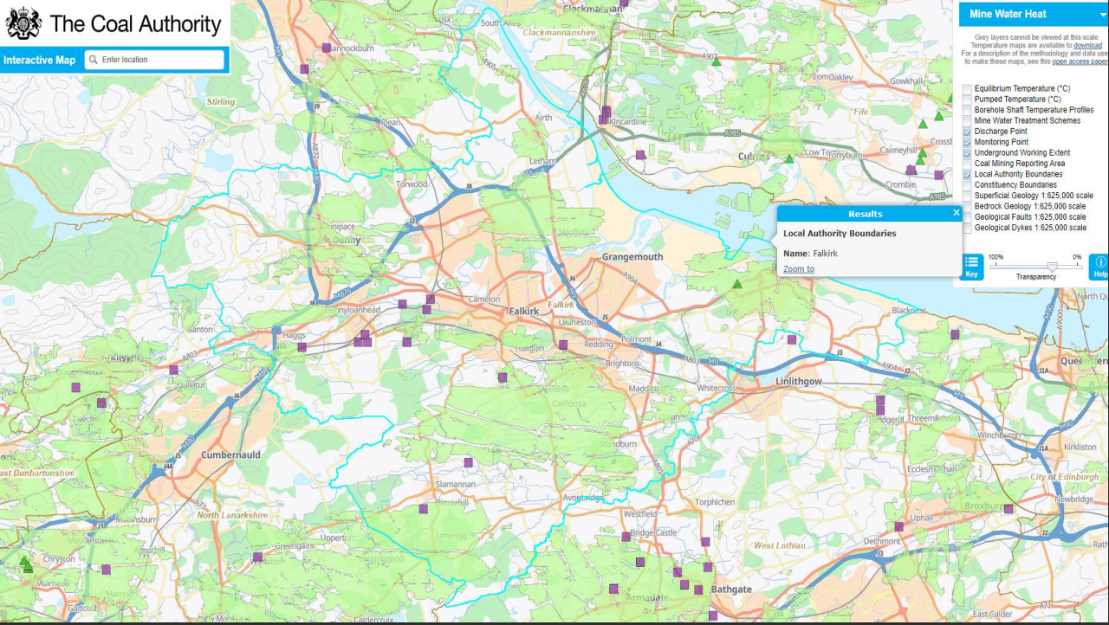

Figure 5: Mine water heat, Coal Authority 2023

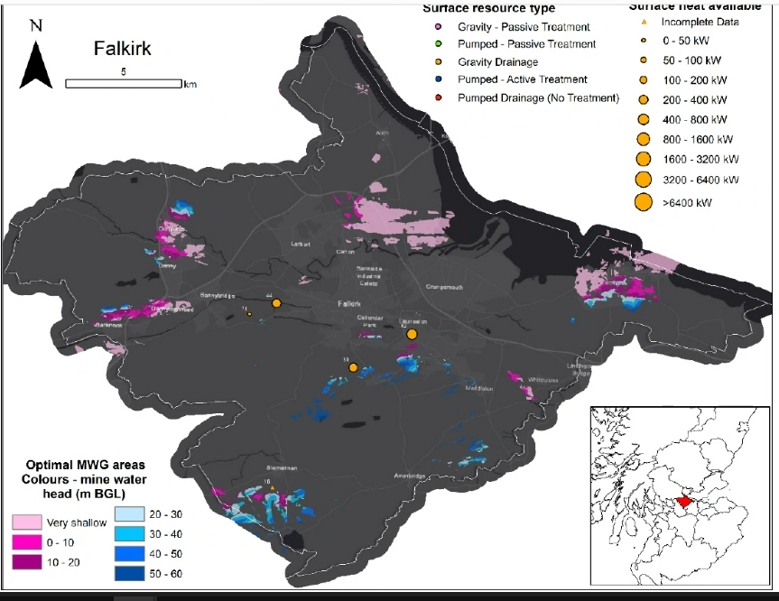

Figure 6: Sewage Water Data, Scottish Water 2023

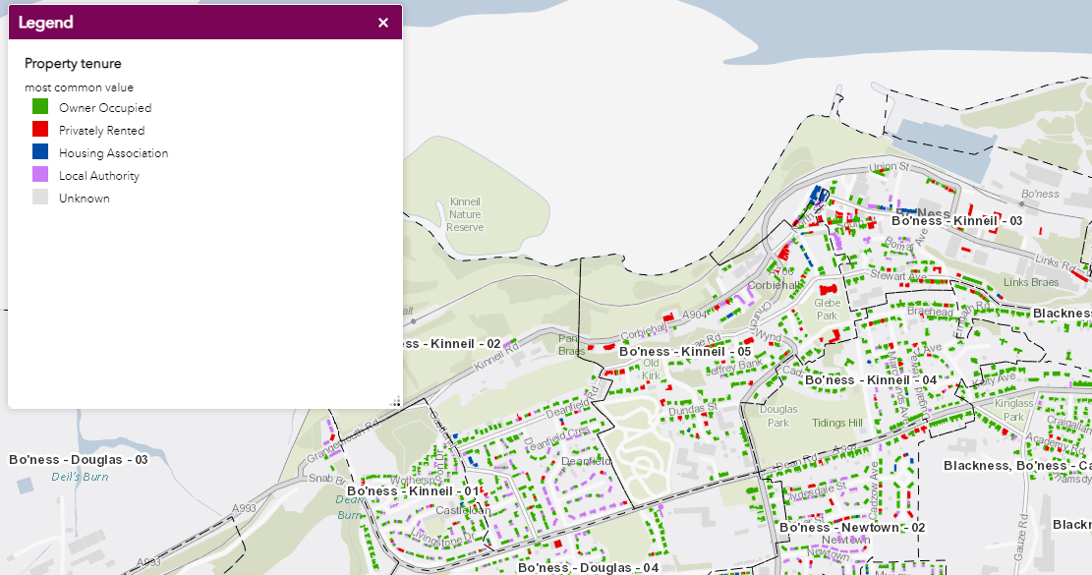
Figure 7: Bo'ness Kinneil Property Tenure (Home Analytics, 2023)

Conclusion

Completion of this initial LHEES Delivery Plan and the LHEES Strategy is intended to help the Scottish Government to understand further the national landscape for LHEES delivery and where there are potential gaps to support the needs and aspirations of local authorities. It would also help to ensure that local authorities are delivering changes to buildings and local infrastructure at a suitable rate to help achieve national targets as set out in the Heat in Buildings Strategy, and that there is a level of standardisation and consistency between local authority LHEES Strategy and Delivery Plans. It is anticipated that both the LHEES Strategy and LHEES Delivery Plan would be updated and renewed on a 5-year cycle. Thus, it is suggested that LHEES Delivery Plans are likely to be considered over two time periods: An initial plan incorporating actions with a near-term (5 year) focus; and a longer-term series of delivery plans that follows-on from and considers the period beyond the initial plan (5 years or longer).
At a national level, the UK and Scottish Governments have a broad range of policies and strategies that legislate and support the various targets to support the LHEES objectives. In particular, the Scottish Government’s policy around heat networks and other technologies which can help achieve decarbonisation objectives are specific and in line with LHEES. From the review of the local policy and strategy it is apparent that Falkirk has a broad range of current and emerging policy which also align with LHEES. There is a strong focus on housing within the Local Authority area, both in terms of developments but also supporting retrofitting activities and residents that may require support with regards to fuel poverty, for example the ASHP project at the Brae’s Villages.
Overall, Falkirk Council officers are working on a wide range of decarbonisation projects including an ASHP project, heat network extension feasibility study, a Solar PV array, and an energy from waste plant. Over the next five years, these projects will assist with Falkirk’s journey towards net zero. The LHEES work will build on existing delivery programmes (e.g. HEEPS:ABS), integrating the delivery areas set out into specific projects or prioritised areas. As stated, the delivery plan covers a 5-year period and will continue to be updated in 5-year increments. Drawing on the LHEES Strategy and the initial plan, the longer term LHEES Delivery Plans are likely to be supported by future standards, delivery programmes and regulation and so there will be a stronger link between the LHEES Strategy and evidence base and how this can align and support the wider heat decarbonisation agenda.

Monitoring and Evaluation

A key part to the success of the LHEES Strategy and Delivery plan will be effective monitoring, evaluation, and reporting on progress. The following mechanisms will be utilised for monitoring and reporting:

- Energy Management monitoring Group – this group has a remit to monitor energy consumption, drive energy decarbonisation projects and monitor progress of projects and their contribution to national and organisational targets. Regular progress updates will be made to this group regarding LHEES and we will also use this as a vehicle to develop and drive projects that support our LHEES.

- Falkirk Council Executive – update reports on Falkirk Council’s progress will be provided to the Executive alongside our climate change update on an annual basis. This will ensure accountability for LHEES, given these are publicly available documents and the public can also watch the meetings online.

- Public Bodies Climate Change Duty Report – this is submitted annually to the Sustainable Scotland Network and all Public Bodies must submit these reports. Part of this reporting includes carbon reducing projects which have taken place in the reporting year and projects due to take place in the next year. We will ensure any projects relating to LHEES are suitably recorded in this report.

The LHEES delivery plan is a working document and as such will be regularly updated as projects indicated in the plan progress and new projects are planned in. Although the requirement of the Local Heat and Energy Efficiency Strategies (Scotland) Order 2022 is to publish an updated version of the delivery plan at intervals of no more than five years after date of publication of previous plan, Falkirk Council is committed to updating our delivery plan on an annual basis alongside updates to our Climate Emergency Action Plan. This updated plan will be reported to Elected Members at the annual climate change update and, following approval, the updated version will be published on our website.
The LHEES Strategy will also be reviewed regularly, and any new policy and legislation added to the strategy. As new policy and policy updates are highly likely Falkirk Council is also committed to updating this element on an annual basis and this will be included in climate change update to Elected Members via the Council Executive.
Falkirk Council’s LHEES Strategy, as a whole, will also be reviewed, updated and published every five years in line with the legislation.

